Written and Oral Communication

Mrs. Kopeny
Room A111
maryann.kopeny@d214.org
(847) 718-5966

Welcome to Written & Oral Communication! The purpose of this year-long interdisciplinary course is to introduce various components of speech, literature, history, and composition in order to create an understanding and appreciation of our world. We will focus on components of communication, composition, grammar, and vocabulary and encompass elements of research as well as speaking and writing for a variety of purposes.

Please do not hesitate to speak with me when you have questions or concerns. I am available during seminar and before and after school on PURPLE days.
Required Texts:

America Now (Atwan, 7th Edition)
Word Within the Word (Thompson)
Magic Lens (Thompson)
Speech for Effective Communication (Holt, Rinehart, and Winston)
WREN workbooks
**To Kill a Mockingbird: course text and media (Lee)—student purchase required
**Of Mice and Men: course text and media (Steinbeck)—student purchase required

“Should you or your parents/guardians have a question regarding course expectations, media or textbooks, or wish to request an alternative assignment for curricula containing potentially objectionable material, please contact the respective Division Head to discuss your concerns. The Division Head will serve as the liaison between the student and parent and the teacher.”

Teachers may use video clips from commercial and basic cable television, current periodicals, as well as articles from local or national newspapers to explain or illustrate scientific concepts or topics without listing them on this website. This includes, but is not limited to, Life, Time, Newsweek, major television networks, Discovery Channel, TLC, Animal Planet, CNN, public television and the like.

EVERYDAY Required Materials:
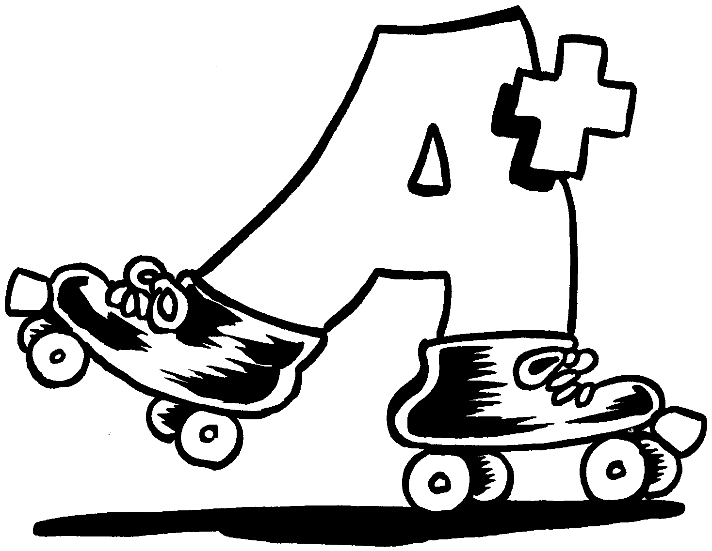
- Pens - Binder with dividers (minimum of 1.5 inches in size)
- Loose-leaf paper - #2 Pencils (NO mechanical pencils)
- School-issued assignment notebook

Grading:
Semester One Grading:
Weight | Category
5% | Summer Reading: Legend or Unbroken
5% | Habits of Work (completing notes/homework, prepared for class, active participation)
10% | Vocabulary
15% | Final Exam
65% | Semester Work (both formative and summative assessments in the following areas: writing, grammar, WREN, reading, speech, poetry, etc)
Posting Grades to HomeLogic:

Minor, daily assignments are graded and updated weekly. For larger projects and/or essays, grades will be updated within three to four weeks. Please feel free to contact me directly with specific questions/concerns at maryann.kopeny@d214.org

PLEASE NOTE: These guidelines are for student work that is completed and turned in at the time it is due. Late work may not be graded according to the timeline established above.

Late Work Policy:

Students are expected to be responsible and complete their work on time. In the event that it is not, late work will be accepted for reduced or partial credit within the course of a given unit. For speeches, students must be prepared to present on their assigned day. If a student is not prepared, he or she may present the following class for reduced or partial credit.

Classroom Expectations:

Academic Integrity

The Rolling Meadows High School/ District 214 Academic Integrity Policy will be strictly enforced. Cheating/ plagiarizing will result in a zero for the assignment. Make sure to do original work on all your assignments because the repercussions will have a negative effect on your grade.

Attendance, Missed Work, and Tardiness

I value our time together, so I expect you to come to class everyday prepared. Remember make-up work is your responsibility for those days absent. Please check the class website for information regarding what you miss: rmhskopeny.weebly.com For missed tests or exams, please see me to make arrangements to make-up the assignment. You will only have until the end of a unit to make up tests and missing work. After this point, all incomplete work will become a “0.”

If you are part of a group and are absent, you must still turn in your portion of the group project that day…give the assignment to a friend, email it, have someone drop it off, etc. Have a plan in place ahead of time for how your work will get to your group if you are gone.

You are late if you are not in your seat when the bell rings. When entering the classroom late, please be courteous and enter quietly and quickly in order to avoid disturbing the class. Ten minutes is more than enough time to get what you need from your locker, make your way around the building, and get to your desk in this class. Remain in your seat from bell to bell. Please do not stand around at the door.

Participation & Behavior

Come to class ready to participate. Discussion is an integral component of an English classroom. Realize that participation includes both contributing thoughts/opinions to class discussions, asking/answering questions, and responding to your peers’ comments. Treat one another with RESPECT and CONSIDERATION. Each student has something to offer the rest of us. In order to take advantage of those learning opportunities, we LISTEN respectfully to each other. You are also responsible for displaying appropriate behavior and language.

Please fill out, sign, and have your student return this portion to class by Friday, August 30.

I have read and understood the expectations for Written and Oral Communication.
________________________________________________
Student Name (PRINT)

________________________________________________
Student Signature

________________________________________________
Parent/Guardian Name (PRINT)

________________________________________________
Parent/Guardian Signature

Email address:____________________________________

Phone number:____________________________________

